**GenAI using LangGraph**

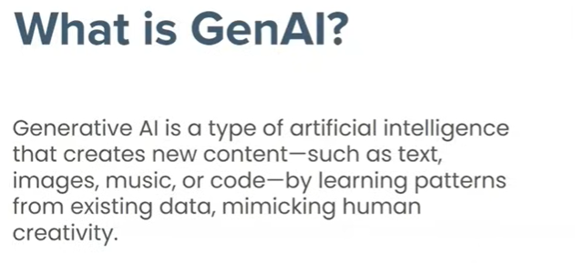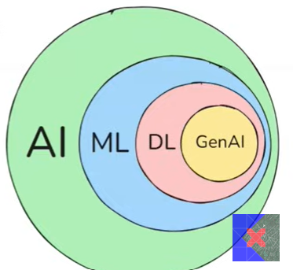

**machine learning created huge impact on generative AI**

**GenAI is replacing human creativity**

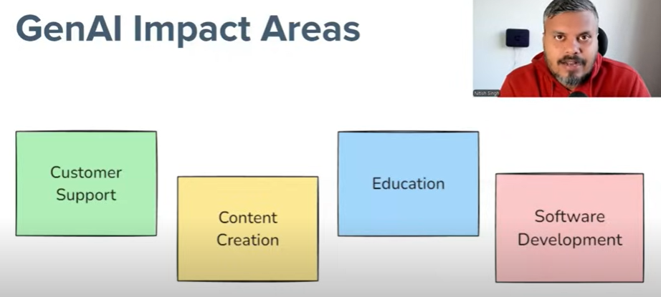

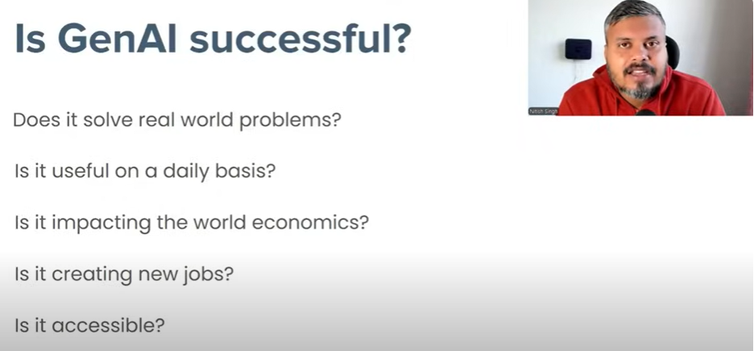

All of above Question have “YES” ANSWERS

**Foundation models is the center of all modes that include LLM, LMM(Large multi model deals with voice image etc)**

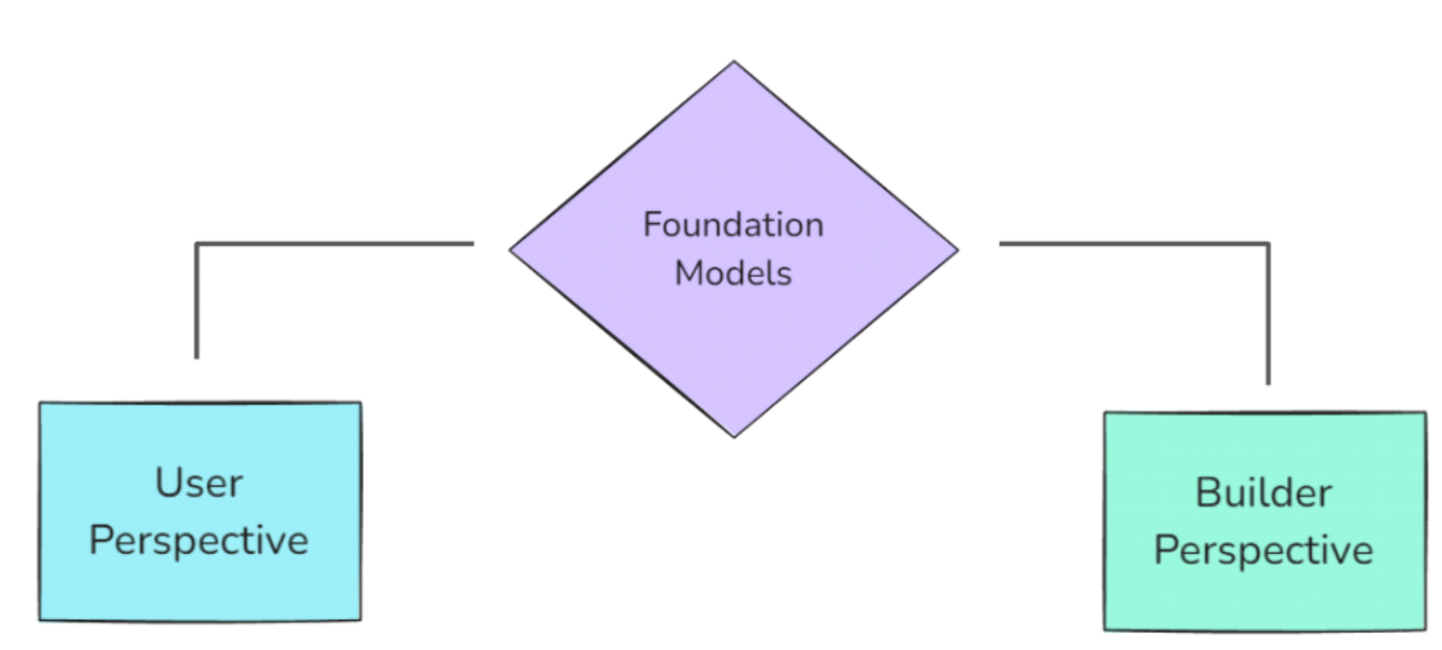

**Users perspective where we use prebuilt model like LLM for your work**

**builders perspective built this foundation model and deploy it like LLM**

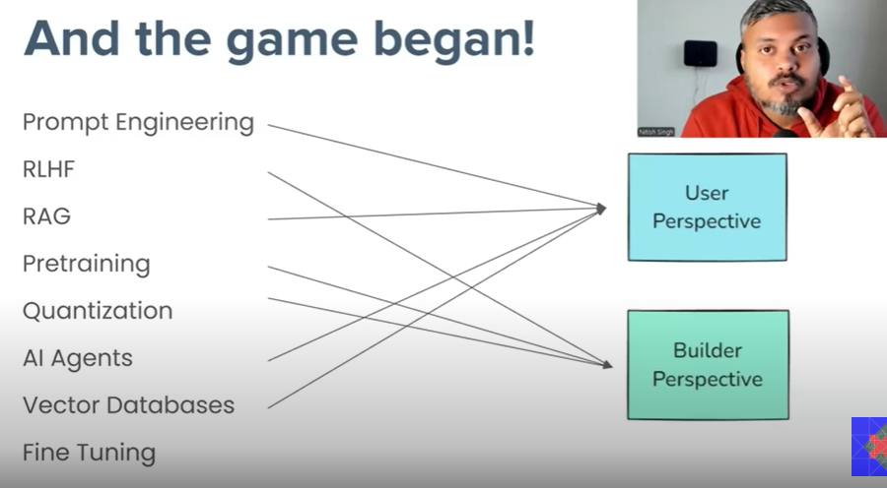

builders perspective should have knowledge of machine learning deep learning and pytorch or tensorflow

